Project Design Phase Problem–SolutionFitTemplate

|  |  |
| --- | --- |
| Date | 24July2025 |
| TeamID | PNT2025TMID09231 |
| ProjectName | VisualizingHousingMarketTrends:AnAnalysis of Sale Prices and Features using Tableau. |
| MaximumMarks | 2Marks |

# Problem–SolutionFitTemplate:

Whatisthecustomerstrugglingwith?

Stakeholdersintherealestatesector—suchasanalysts,marketingteams,andexecutives—face challenges in:

* Identifyingwhichpropertyfeaturesinfluencepricingtrends
* Understandinghowrenovationsaffectbuyerinterestandprice
* Makingstrategicdecisionswithoutdata-backedinsights
* Communicatingpropertytrendseffectivelytoclientsorinvestors

# Purpose:

* Solvingcomplexchallengesinrealestateanalysisthroughactionable,data-driveninsights.
* Acceleratingadoptionbyaligningsolutions(e.g.,Tableauvisualizations)withexisting behaviors and decision-making patterns.
* Sharpeningstrategyandcommunication,ensuringthatdashboards,insights,andstories speak directly to stakeholder needs.
* Buildingtrustwithusersbysolvingfrequentannoyanceslikeuncleartrends,pricing confusion, or unstructured data.
* Understandingthecurrentworkflowsandgapsinanalysis,sothefinalsolutionisaclear, effective improvement.

# Template:

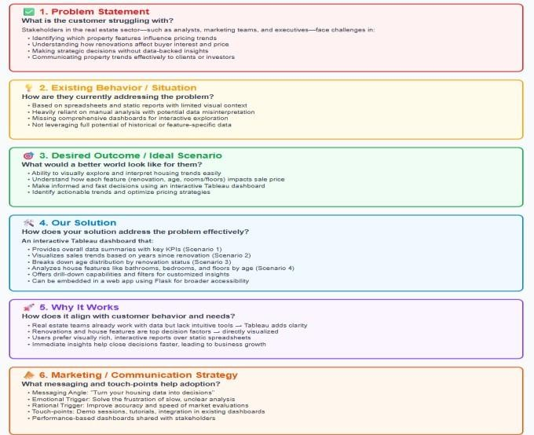

References:

1. CustomerdevelopmenttheoriesbySteveBlank.
2. LeanStartupmethodologybyEricRies.
3. TableaudocumentationandrealestateBIcasestudies.
4. Behavioraleconomicsappliedtotechadoption(NirEyal’sHookedModel).